**TABLE OF CONTENT**

|  |  |  |
| --- | --- | --- |
| **S.NO** | **TOPIC** | **PAGE** |
|  | **Declaration** |  |
|  | **Acknowledgement** |  |
|  | **Certificate** |  |
|  | **Abstract** |  |
| 1 | **Introduction**  1.1 Purpose  1.2 Scope  1.3 Aim   * 1. Objectives |  |
|  |  |  |
| 2 | **Requirements** |  |
|  | 2.1 Process Architecture |  |
|  | 2.2 Business Requirements  2.2.1 High Level Requirements  2.2.2 Detailed Functional Requirements |  |
|  | 2.3 Database Requirements |  |
|  | 2.4 Technology & Tools Requirements |  |
|  |  |  |
| 3 | **Functional and non-functional requirements** |  |
|  | 3.1 External Interface Requirements |  |
|  | 3.2 Non Functional Requirements |  |
|  | 3.3 Availability |  |
|  | 3.4 Performance |  |
|  | 3.5 Technologies |  |
| 4 | **Analysis Diagram** |  |
|  | 4.1.1 Context analysis diagram |  |
|  | 4.1.2 First DFD diagram |  |
|  | 4.1.3 Second DFD diagram |  |
|  | 4.1.4 Login Activity diagram |  |
|  | 4.1.5 Implementation view |  |
|  | 4.2 ER diagram |  |
| 5 | **Bibliography and references** |  |
|  |  |  |
|  |  |  |

**INTRODUCTION**

Online shopping is the process whereby consumers directly buy goods or services from a seller in real-time, without an intermediary service, over the Internet. It is a form of electronic commerce. An online shop, eshop, e-store, internet shop, webshop, online store, or virtual store evokes the physical analogy of buying products or services at a bricks-and-mortar retailer or in a shopping centre.The process is called Business-toConsumer (B2C) online shopping.

**Project Overview:**

The shopping cart project needs to create the shopping cart system to organize the products record and the other information about the customers. How customers can buy products from website can be recognized from their username and password.

**Scope:**

Online shopping is rising day by day in India. Because India is the country where computer user's are increasing day by day so as the online shopping trends are also increasing. This project covers the online selling of cosmetics, fashion accessories, watches etc. The project shows the product category and then product details. From the product details, the product can be added to cart and can be bought.

**Aims and Objective:-**

The main purpose behind the proposed system is to provide a comprehensive computerized system, which can capture, collate and analyze the data and evaluate the impact of the program.

Characteristics of the proposed system:

The web application has following features:

• In comparison to the present system the proposed system will be less time consuming and is more efficient.

• Analysis will be very easy in proposed system as it is automated.

• The proposed system is very secure as no chances of loss of data as it is dependent on the administrator only.

**FUNCTIONAL AND NON-FUNCTIONAL REQUIREMENTS :**

Required website is to provide online details to the customers of the specified products. The system should satisfy the following requirements:

General Aspects:

Authenticate User Show Products and their details with type Website should be able to register new user.

Analysis: Authenticate user based on username & password. Keeping session track of user activity.

Maintaining the record of products.

**3.1 External Interface Requirements:**

3.1.1 Hardware Interface

• Server side Hardware

• Hardware Recommended by the all the software needed

• Communication hardware to server client request.

• Client side Hardware

• Hardware recommended by respective client operating system & Web browser.

• Communication hardware to communicate the server.

3.1.2 Software Interface

• Server side software

• Web-Server software

• Database tools (Sql Database is mandatory)

• Compatible operating system

**3.2 Non Functional Requirements**

• System should be able to handle multiple users.

• Login by username, password should be incorporated wherever necessary

• Should be user friendly and display easy to understand error messages 3.3 Reliability Data validation & verification need to be done at every stage of activity. Validation user input.

**3.3 Availability**

• The web application should be available anywhere and anytime.

• User Session should timeout after 20 minutes of inactivity.

**3.4 Performance**

The system will be used by multiple users and may grow as time passes. Necessary measures need to be taken to make the system as fast as possible.

**3.5 Technologies**

The sections list all the technologies for the web based system. This project is a web based application that is developed in ASP.NET having Sql-Server as backend. Database design (Sql server 2008 R2) Input design (ASP.NET with C#) Coding (C#)

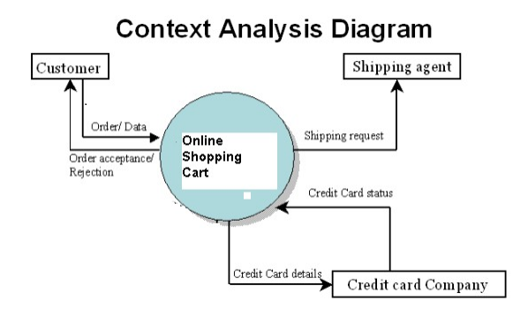

**4.1.2 First Level DFD Diagram:**

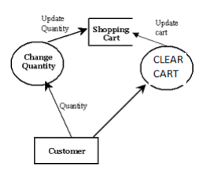

**4.1.3 Second level DFD Diagram:**

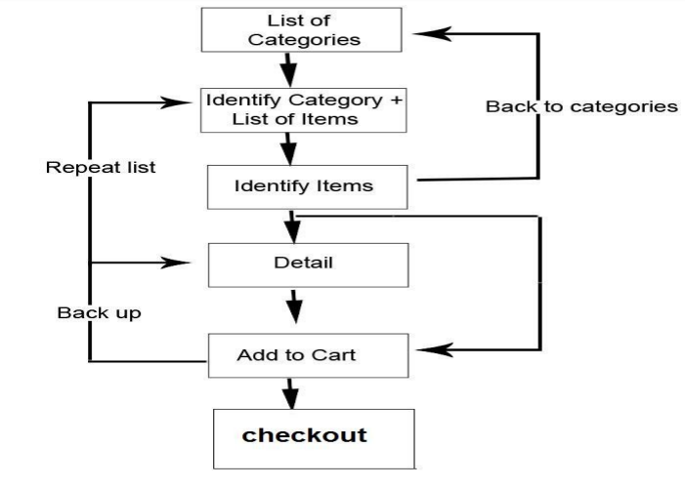

**4.1.4 Login Activity Diagram:**

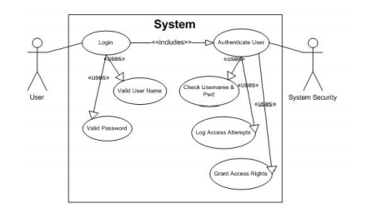

**4.1.5 Implementation View:**

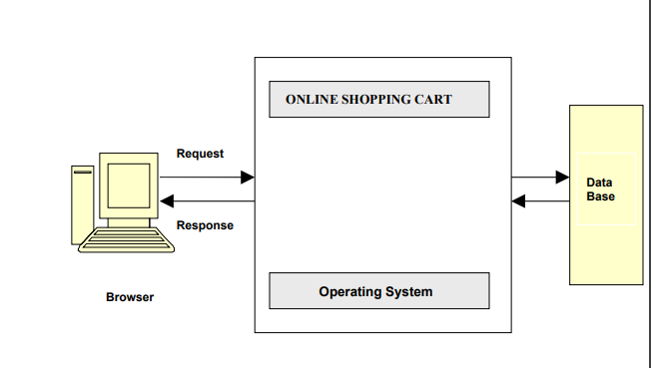

**4.2 E-R Diagram:**

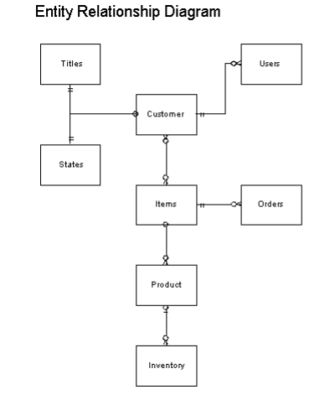

**6.Bibliography & References**

1. "W3Schools Online Web Tutorials", *W3schools.com*, 2019. [Online]. Available: <https://www.w3schools.com/>.
2. https://stackoverflow.com